1.
Log in to Cisco Packet Tracer or any network simulation tool, add a switch, and create two VLANs named 'Sales' and 'Support' with VLAN IDs 10 and 20.
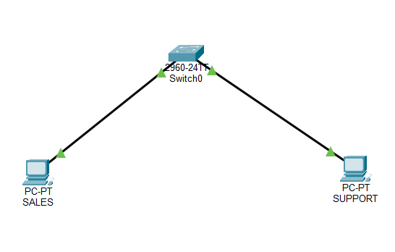

2.
Assign three different switch ports to VLAN 10 (Sales) and two ports to VLAN 20 (Support), then verify the VLAN membership using the show vlan command.<br><br><em><strong>Hint:</strong> Use the interface range command to select multiple ports efficiently.</em>
configure terminal
interface range fa0/1-3
switchport mode access
switchport access vlan 10
exit
interface range fa0/4-5
switchport mode access
switchport access vlan 20
exit
end
show vlan brief

3.
Connect two routers using a serial or Ethernet link in your simulation tool, assign IP addresses to their interfaces, and configure a static route on Router 1 to reach the LAN behind Router 2.
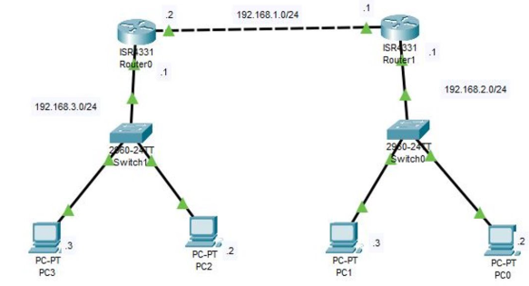
4.
Simulate a scenario where a device in the 'Sales' VLAN tries to ping a device in the 'Support' VLAN and explain why the ping fails, then suggest what configuration would allow inter-VLAN communication.<br><br><em><strong>Hint:</strong> Think about router-on-a-stick or Layer 3 switch concepts.</em>
Test scenario: Connect one PC to VLAN 10 (Sales) and another PC to VLAN 20 (Support). Assign them IP addresses in different subnets, such as 192.168.10.2/24 and 192.168.20.2/24.
Try pinging the Support PC from the Sales PC:
ping 192.168.20.2
Why does the ping fail?
By default, VLAN 10 and VLAN 20 are separate Layer 2 broadcast domains. A normal Layer 2 switch does not route traffic between them, so devices in different VLANs cannot communicate without a Layer 3 routing configuration.
- Result: VLAN creation and port assignment isolate Sales and Support. Inter-VLAN routing enables communication between them when correctly configured.

